PHYSICS 3600 Optics and Photonics I
Winter 2006

Assignment #1
Handout: Wednesday, January 18, 9:00 am

Due: Wednesday, January 25, 9:00 am

Note: There are six problems in this assignment.

- (15points) Show that the lateral displacement D of a ray of light penetrating a rectangular plate of thickness d is given by $D=d\text{sin}θ_{1}\left(1−\frac{n_{1}\text{cos}θ_{1}}{\sqrt{n_{2}^{2}−n_{1}^{2}{\text{sin}}^{2}θ_{1}}}\right)$

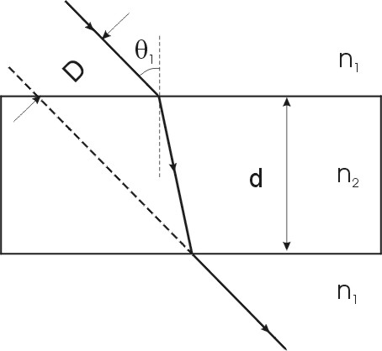

- (15 points) Derive the mirror equation for a concave mirror.
- (15 points) A ray of light makes an angle of incidence of 45° at the centre of the top surface of a transparent cube of refractive index 1.414. Trace the ray through the cube.
- (15 points) A fish is one meter below the surface of a pond. If you are looking more or less vertically down at the fish, how deep does it appear to you to be? (The refractive index of water is 1.33.)
- (20 points) An object is distance s from a spherical mirror of radius of curvature R. Find an expression for the magnification, m, in terms of R and s only. Plot or sketch a graph of m versus s for R = 20 cm, and for R= -20 cm.
- (20 points) (For your convenience, you may copy and paste the diagrams here into your homework)
(a) Show, by drawing the paths of at least two rays, where the image of the object appears in the diagram below. Then calculate the position of the image, state what the magnification is and state whether the image is real or virtual. The object is 15 cm from the mirror.

(b) Repeat the steps in (a), but for an object 5 cm from the mirror, as shown below. Note that here s < f. Is it ever possible that s' can be < f?

